Examination Management System (EMS)

Project Overview
The Examination Management System (EMS) is a centralized, enterprise-grade web platform designed to streamline and automate the complete examination lifecycle for educational institutions. The system acts as the central orchestration layer for all examination-related activities, beginning with examination planning and configuration, continuing through fee management, student registration, payment processing, and concluding with hall ticket generation, marks management, result publication, and reporting.
Rather than functioning as a standalone student information system, the Examination Management System integrates with the existing SDMS (Student Data Management System), which serves as the master source for academic information such as colleges, courses, academic years, branches, semesters, batches, and student records. By synchronizing this master data, the examination portal focuses exclusively on examination operations without duplicating academic administration.
The platform enables the Examination Cell to configure regulations, define subjects for each regulation, map subjects to eligible batches and semesters, create examinations, configure subject-wise and package-based fee structures, manage approval workflows, publish examinations, and automatically generate examination fee records for eligible students.
Students can securely log in using their existing SDMS credentials to access examination notifications, view eligible examinations, check subject details, monitor fee status, pay examination fees online, download receipts, access hall tickets, and view examination results. The Accounts Department can also collect examination fees through offline payment modes such as cash or bank transactions, ensuring support for both digital and traditional fee collection processes.
Designed using a modular architecture and modern web technologies, the platform emphasizes scalability, security, maintainability, and seamless integration with institutional systems, providing a unified solution for end-to-end examination orchestration.

Project Objective
The primary objective of the Examination Management System is to establish a centralized platform that efficiently manages and automates every stage of the examination process. The system aims to reduce manual intervention, eliminate repetitive administrative tasks, minimize errors in examination management, and provide a transparent, secure, and scalable environment for students, examination staff, and administrators.

Project Scope
The scope of the Examination Management System encompasses the complete orchestration of examinations from configuration to result publication.
The system includes:
- Synchronization of academic master data from the SDMS Portal
- Regulation Management
- Subject Management
- Subject-to-Regulation Mapping
- Batch and Semester Mapping
- Examination Creation and Configuration
- Examination Approval Workflow
- Examination Publication
- Examination Fee Configuration
- Automatic Fee Generation
- Student Examination Dashboard
- Online Examination Fee Payment
- Offline Fee Collection (Cash/Bank)
- Late Fee and Fine Management
- Hall Ticket Generation
- Hall Ticket Distribution
- Marks Entry
- Result Processing and Publication
- Notifications and Alerts
- Reports and Analytics
- Audit Logs
- Role-Based Access Control
- Integration with Existing College Systems

Key Features

Academic Configuration
- Regulation Management
- Subject Management
- Subject Mapping
- Semester Mapping
- Batch Mapping

Examination Management
- Exam Creation
- Subject Selection
- Timetable Configuration
- Fee Configuration
- Approval Workflow
- Exam Publication

Fee Management
- Subject-wise Fee
- Package Fee
- Late Fee
- Fine Management
- Online Payments
- Offline Payments
- Receipt Generation

Student Services
- Student Login
- Examination Dashboard
- Fee Status
- Online Payment
- Hall Ticket Download
- Result Viewing
- Payment History

Administrative Services
- Examination Approval
- Accounts Dashboard
- Reports
- Analytics
- Audit Logs
- User Management

Technology Stack
Layer | Technology
Frontend | Next.js
Language | TypeScript
Backend | Node.js + Express.js
Primary Database | MySQL
Transaction Database | MongoDB
Authentication | JWT + SDMS Authentication Integration
API Architecture | REST APIs
File Storage | AWS S3 / Local Storage (Configurable)
Payment Gateway | Razorpay / Cashfree (Configurable)
Cache | Redis (Future Enhancement)
Deployment | Docker + AWS / On-Premise

MongoDB (Transactional Database)
MongoDB is dedicated to handling high-volume transactional operations and payment-related activities where flexibility, scalability, and auditability are essential.
It stores:
- Examination Fee Records
- Payment Transactions
- Payment Gateway Responses
- Receipt Information
- Payment History
- Refund Requests
- Transaction Logs
- Webhook Responses
- Payment Audit Trail
Separating payment transactions into MongoDB enables efficient handling of concurrent payment requests during peak examination periods while keeping financial transaction data isolated from academic records.

System Integration
The Examination Portal integrates directly with the existing SDMS ecosystem.

SDMS Provides
- Colleges
- Courses
- Academic Years
- Branches
- Semesters
- Batches
- Students
- Student Authentication

Examination Portal Manages
- Regulations
- Subjects
- Exams
- Fee Structures
- Payments
- Hall Tickets
- Marks
- Results
- Reports
Core Workflow
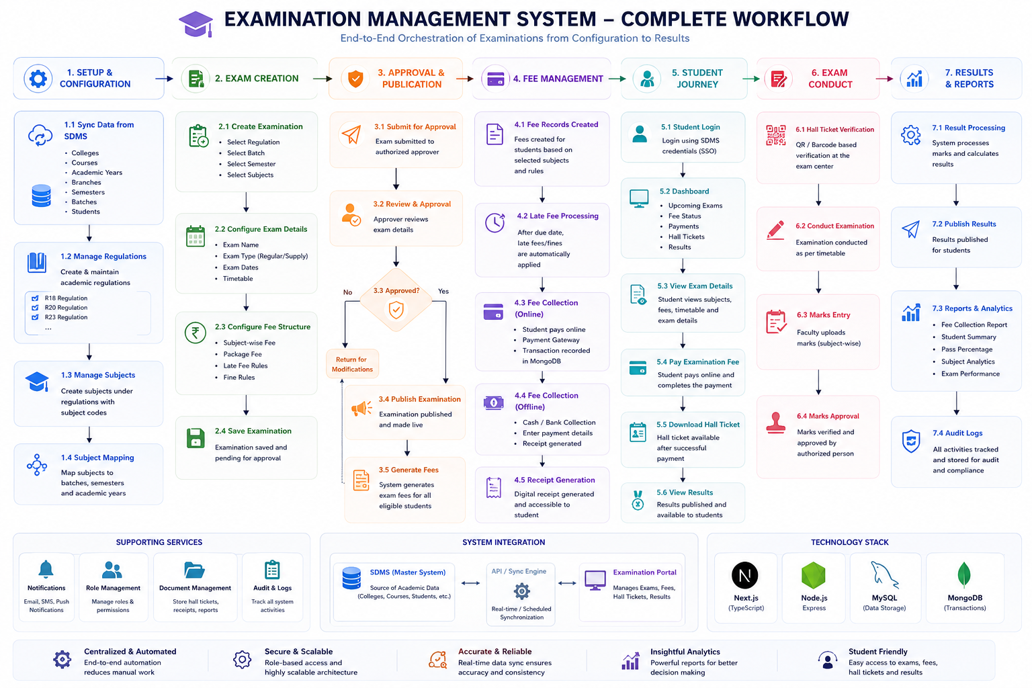

Architecture Principles
The Examination Management System is designed around the following principles:
- Centralized Examination Orchestration – A single platform manages the entire examination lifecycle.
- Separation of Concerns – Academic data remains in SDMS, while examination-specific operations are handled by EMS.
- Modular Design – Independent modules for regulations, subjects, exams, fees, payments, hall tickets, and results.
- Scalable Infrastructure – Capable of supporting thousands of concurrent users during peak examination periods.
- Secure Transactions – Dedicated transaction management with comprehensive payment auditing.
- Configuration-Driven – Examination rules, fee structures, regulations, and workflows are configurable without code changes.
- Integration Ready – RESTful APIs and synchronization mechanisms enable seamless integration with existing ERP systems.
- Role-Based Access Control – Fine-grained permissions for administrators, examination cell staff, accounts personnel, faculty, and students.

Vision Statement
To provide a centralized, scalable, and secure Examination Management System that simplifies examination orchestration through automation, seamless integration with institutional systems, and a modern digital experience for students, examination administrators, and accounts personnel.

Workflow 3: Subject Management

Overview
The Subject Management module enables the Examination Cell to create and manage subjects under their respective academic regulations. Every subject belongs to a specific regulation and contains complete academic metadata required for examination scheduling, fee calculation, hall ticket generation, marks entry, and result processing.
Since different regulations may contain different subject codes, credits, and semester structures, subjects are maintained independently for each regulation.

Purpose
The primary purpose of this module is to maintain a centralized repository of all examination subjects while ensuring that every subject is correctly associated with its corresponding regulation.
This module acts as the foundation for examination creation, subject mapping, and student eligibility determination.

Functional Flow
- Examination Cell selects an existing regulation.
- The system opens the Subject Management page.
- Administrator enters subject details.
- System validates mandatory fields.
- Duplicate subject codes are verified.
- Subject information is saved.
- Subject becomes available for mapping and examination creation.

Subject Information
Each subject contains the following information:
Field | Description
Subject Code | Unique subject identifier under a regulation
Subject Name | Official subject title
Regulation | Associated academic regulation
Semester | Applicable semester
Subject Type | Theory / Practical / Laboratory
Credits | Subject credits
Internal Marks | Internal assessment marks
External Marks | External examination marks
Total Marks | Maximum marks
Status | Active / Inactive

Validation Rules
- Subject Code must be unique within a regulation.
- Subject Name is mandatory.
- Semester must exist.
- Credits cannot be negative.
- Duplicate subject codes are not allowed.
- Subject cannot be deleted if already used in an examination.

Output
Successfully created subjects become available for:
- Subject Mapping
- Examination Creation
- Fee Configuration
- Hall Ticket Generation
- Marks Entry
- Result Processing

Workflow 4: Subject Mapping

Overview
The Subject Mapping module associates subjects with specific academic batches, semesters, branches, and courses. This mapping enables the system to determine which students are eligible for a particular examination.
Rather than manually selecting students during examination creation, the system automatically identifies eligible students based on predefined mappings.

Purpose
The purpose of this module is to establish the relationship between academic regulations, courses, branches, semesters, batches, and their corresponding subjects.
This ensures that examination creation and fee generation occur automatically for the correct group of students.

Functional Flow
- Administrator selects a regulation.
- Selects the applicable course.
- Selects the branch.
- Selects the academic batch.
- Selects the semester.
- System displays available subjects.
- Administrator selects applicable subjects.
- Mapping is saved.
- Subjects become eligible for examination creation.

Mapping Components
Component | Description
Regulation | Academic Regulation
Course | Degree Program
Branch | Department
Batch | Admission Batch
Semester | Academic Semester
Subjects | List of Applicable Subjects

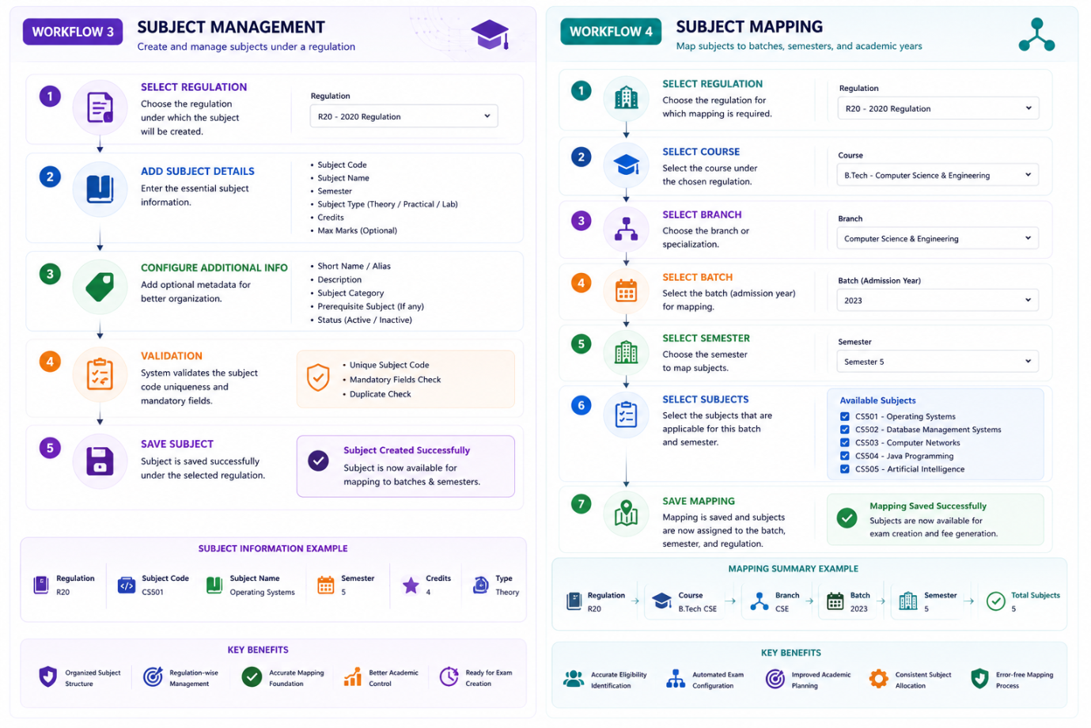

Workflow 5: Examination Creation

Overview
The Examination Creation module is the core component of the Examination Management System. It enables the Examination Cell to configure and organize examination sessions by selecting the applicable regulation, academic hierarchy, mapped subjects, fee structure, schedules, and examination rules.
The module is designed to automate the examination setup process while ensuring that only eligible students belonging to the selected regulation, batch, branch, and semester can participate in the examination.

Purpose
The primary objective of this module is to simplify the creation of examination sessions through a configuration-driven approach, eliminating repetitive manual work and reducing administrative errors.
The module ensures that examination details, fee structures, schedules, and eligibility rules are centrally managed before the examination is published.

Functional Flow
- Examination Cell initiates examination creation.
- Select the applicable regulation.
- Select the course, branch, batch, and semester.
- System retrieves all mapped subjects automatically.
- Administrator selects the subjects for the examination.
- Configure subject-wise examination fees.
- Configure package examination fee (if applicable).
- Enter examination details.
- Configure application and payment dates.
- Configure late fee and penalty rules.
- Add examination instructions and supporting documents.
- Review the complete configuration.
- Save the examination.
- Examination status becomes Pending Approval.

Examination Configuration
Each examination contains the following information:
Field | Description
Examination Name | Name of the examination
Examination Type | Regular / Supply / Improvement / Special Supply
Regulation | Applicable Regulation
Course | Degree Program
Branch | Department
Batch | Admission Batch
Semester | Applicable Semester
Subjects | Selected Examination Subjects
Examination Start Date | Start Date
Examination End Date | End Date
Application Start Date | Fee Registration Start Date
Application End Date | Last Date for Fee Payment
Late Fee Start Date | Late Fee Applicable From
Package Fee | Complete Examination Fee
Subject Fee | Individual Subject Fee
Examination Status | Draft / Pending Approval / Published

Fee Configuration
The Examination Creation module supports multiple fee structures.

Subject-wise Fee
Students are charged individually for every selected subject.
Example:
Subject | Fee
Operating Systems | ₹180
DBMS | ₹180
Computer Networks | ₹180

Package Fee
Students applying for all subjects may be offered a package fee.
Example:
Total Subject Fee | ₹720
Package Fee | ₹600
The system automatically applies the most appropriate fee based on the selected subjects.

Business Rules
- Regulation must exist.
- Subject mapping must be completed before examination creation.
- Examination dates cannot overlap existing examinations for the same academic scope.
- Application end date must be earlier than the examination date.
- Package fee cannot exceed configured limits.
- At least one subject must be selected.
- Examination cannot be published before approval.

Output
Upon successful creation:
- Examination record is created.
- Selected subjects are linked to the examination.
- Fee configuration is stored.
- Examination remains in Pending Approval status.
- Examination becomes available in the Approval Queue.

Workflow 6: Examination Approval

Overview
The Examination Approval module ensures that every examination undergoes administrative verification before it becomes available to students.
This approval mechanism provides an additional validation layer, ensuring that examination schedules, subjects, fee structures, and eligibility criteria are accurate and comply with institutional policies.

Purpose
The purpose of this module is to establish a controlled approval workflow that prevents incomplete or incorrect examination configurations from being published.
Only approved examinations proceed to fee generation and student registration.

Functional Flow
- Administrator opens the Pending Examination Queue.
- Select an examination for review.
- Verify examination information.
- Validate subject mappings.
- Verify fee configuration.
- Review application dates.
- Review examination schedule.
- Review late fee rules.
- Approve or reject the examination.
- If rejected, examination is returned to the Examination Cell with remarks.
- If approved, examination status changes to Approved.
- Approved examinations become eligible for publication.

Approval Checklist
During approval, the administrator verifies:
- Regulation
- Course
- Branch
- Batch
- Semester
- Subject Selection
- Examination Dates
- Timetable
- Subject Fees
- Package Fee
- Late Fee Rules
- Student Eligibility
- Examination Instructions

Decision Workflow

Approved
If all validations are successful:
- Examination Status → Approved
- Examination moves to Publication Workflow
- Fee Generation becomes available
- Students can access the examination after publication

Rejected
If any issues are identified:
- Examination Status → Rejected
- Administrator provides remarks
- Examination returns to the Examination Cell
- Examination can be modified and resubmitted

Business Rules
- Only authorized approvers can approve examinations.
- Every approval action is recorded in the audit log.
- Rejected examinations cannot be published.
- Approved examinations become read-only except for authorized administrative modifications.
- Every approval records:
  - Approver Name
  - Approval Date
  - Remarks
  - Status

Output
After successful approval:
- Examination status changes to Approved.
- Examination enters the Publication Queue.
- Fee generation process becomes available.
- Notification workflow can be initiated.
- Examination is ready for publication to eligible students.

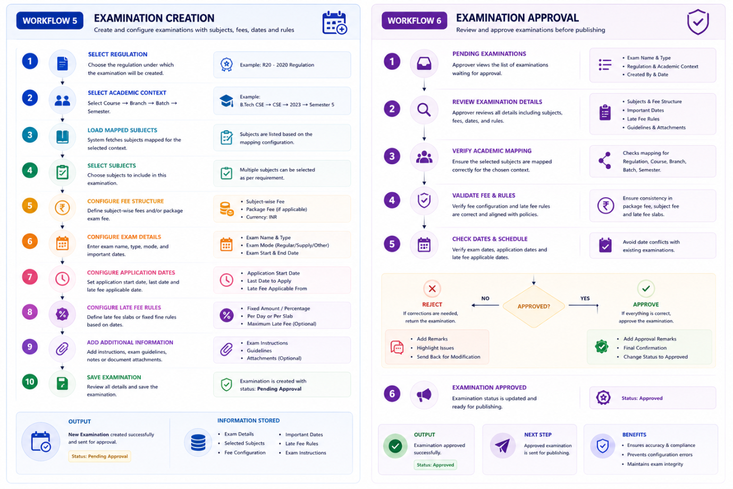

Workflow 7: Examination Publication

Overview
The Examination Publication module is responsible for making an approved examination available to all eligible students. Once an examination has successfully passed the approval process, it is published by the Examination Cell, making it visible within the student portal and initiating all downstream processes such as examination fee generation and student notifications.
Publishing an examination marks the transition from administrative configuration to student interaction.

Purpose
The primary purpose of this module is to officially release an approved examination so that eligible students can begin the examination registration and fee payment process.
This module also triggers the automatic generation of examination fee records for every eligible student based on the configured eligibility criteria.

Functional Flow
- Administrator opens the Approved Examination Queue.
- Selects the examination to publish.
- Reviews the final examination details.
- Publishes the examination.
- Examination becomes visible to eligible students.
- Fee generation process is automatically initiated.
- Students receive examination notifications.
- Publication activity is recorded in the audit log.

Publication Information
Each published examination includes:
Field | Description
Examination Name | Official examination title
Examination Type | Regular / Supply / Improvement
Regulation | Applicable Regulation
Course | Degree Program
Branch | Department
Batch | Admission Batch
Semester | Applicable Semester
Examination Schedule | Subject-wise timetable
Application Dates | Registration period
Fee Details | Subject-wise and package fee
Status | Published

Business Rules
- Only approved examinations can be published.
- Examination details become read-only after publication.
- Publication automatically triggers fee generation.
- Students can only view examinations matching their academic profile.
- All publication activities are logged for auditing.

System Actions After Publication
Once an examination is published, the system automatically performs the following operations:
- Makes the examination visible in the Student Dashboard.
- Displays examination timetable.
- Enables examination registration.
- Initiates examination fee generation.
- Sends notifications to eligible students.
- Records publication history.
- Updates examination status to Published.

Notifications
Eligible students receive notifications through configured communication channels such as:
- Email
- SMS
- In-App Notifications
- WhatsApp (Optional)
Notification includes:
- Examination Name
- Registration Start Date
- Last Date for Fee Payment
- Examination Schedule
- Fee Details

Output
After successful publication:
- Examination becomes publicly available to eligible students.
- Student registration window opens.
- Fee generation process starts.
- Notification service is triggered.
- Examination status changes to Published.

Workflow 8: Examination Fee Generation

Overview
The Examination Fee Generation module automatically creates examination fee records for all eligible students immediately after an examination is published.
Rather than manually assigning fees to individual students, the system evaluates eligibility based on the selected regulation, course, branch, batch, semester, and subject mappings before generating personalized fee records.

Purpose
The objective of this module is to automate the creation of examination fee records while ensuring that each student is charged according to the configured fee structure and examination rules.
This significantly reduces manual effort, improves accuracy, and ensures consistency across the institution.

Functional Flow
- Published examination triggers fee generation.
- System identifies eligible students.
- Retrieves mapped examination subjects.
- Calculates examination fee.
- Applies package fee if applicable.
- Applies subject-wise fee for partial selections.
- Creates examination fee record.
- Stores fee details in the transaction database.
- Updates student fee status.
- Sends fee notification to students.

Student Eligibility Criteria
A student is eligible only if all the following conditions are satisfied:
- Belongs to the selected regulation.
- Belongs to the selected course.
- Belongs to the selected branch.
- Belongs to the selected batch.
- Belongs to the selected semester.
- Student status is Active.
- Student is eligible to appear for the examination.

Fee Calculation Logic
The system supports two fee calculation methods.

Subject-wise Fee
Students are charged only for the selected subjects.
Example:
Subject | Fee
Operating Systems | ₹180
DBMS | ₹180
Java Programming | ₹180
Total Fee = ₹540

Package Fee
When all subjects are selected, the configured package fee is applied.
Example:
Subject-wise Total | ₹720
Package Fee | ₹600
The system automatically selects the package fee if it is more beneficial according to the configured examination rules.

Fee Components
Each generated fee record contains:
Component | Description
Examination Fee | Base examination fee
Subject Fee | Fee for selected subjects
Package Fee | Complete examination fee
Late Fee | Applied after due date
Fine | Administrative penalty (if applicable)
Total Amount | Final payable amount

Database Storage
Each fee record includes:
- Student ID
- Examination ID
- Selected Subjects
- Fee Breakdown
- Total Amount
- Payment Status
- Transaction Reference
- Generated Date
- Due Date
- Audit Information
Fee records are stored in the MongoDB Transaction Database to efficiently handle high-volume payment transactions and support concurrent payment requests.

Business Rules
- Fee records are generated only for published examinations.
- One fee record is created per eligible student.
- Duplicate fee records are not allowed.
- Fee calculation follows configured examination rules.
- Package fee is applied only when applicable.
- Late fee is calculated dynamically after the due date.
- Payment status is initialized as Pending.

Output
After successful fee generation:
- Examination fee records are created for all eligible students.
- Students can view their examination fees in the Student Dashboard.
- Accounts Department can access fee records for offline collection.
- Online payment becomes available.
- Payment status is initialized as Pending.
- Fee generation activity is recorded in the audit log.
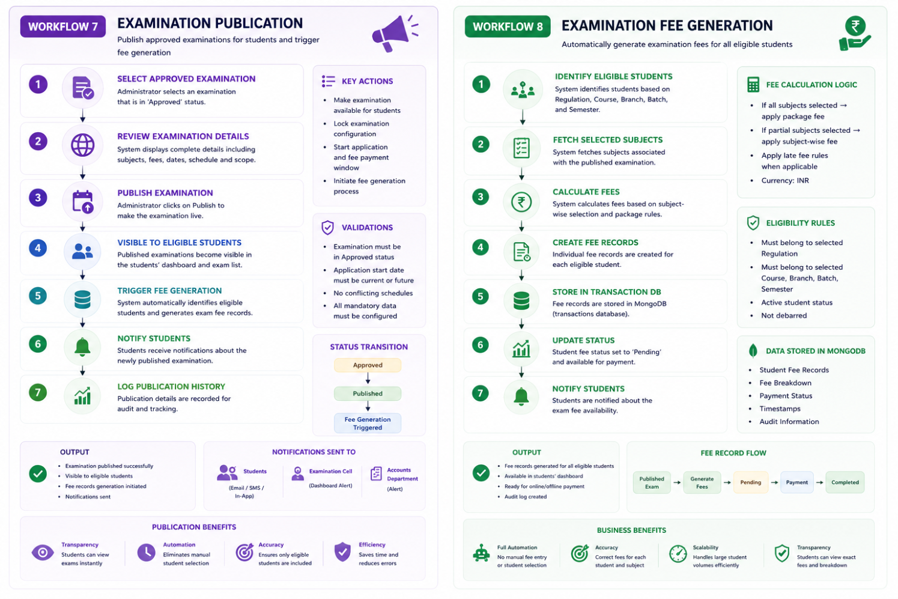

Workflow 9: Examination Fee Payment (Online & Offline)

Overview
The Examination Fee Payment module enables students to pay their examination fees through secure online payment gateways, while also allowing the Accounts Department to collect fees through offline payment modes such as cash or bank transactions.
The module provides a unified fee management system where both online and offline payments update the same examination fee record, ensuring consistency across the institution.
Unlike online payments, offline fee collection is performed only by authorized Accounts personnel, who search and select the student before collecting the payment.

Purpose
The primary objective of this module is to provide a flexible and secure examination fee collection mechanism that supports both digital and manual payment methods while maintaining complete transaction history and auditability.

Payment Methods
The system supports two payment methods:

Online Payment
Performed by:
- Student
Payment Modes
- UPI
- Debit Card
- Credit Card
- Net Banking
- Wallets (Optional)

Offline Payment
Performed by:
- Accounts Department
- Fee Collection Staff
Payment Modes
- Cash
- Bank Transfer
- Demand Draft (Optional)
- POS/Card Machine (Optional)

Online Payment Workflow

Functional Flow
- Student logs in using SDMS credentials.
- Opens Examination Dashboard.
- Views pending examination fees.
- Reviews examination details and payable amount.
- Clicks Pay Now.
- System redirects to the payment gateway.
- Student completes payment.
- Payment gateway verifies the transaction.
- System updates payment status.
- Digital receipt is generated.
- Hall Ticket eligibility is updated.

Business Rules
- Student can pay only his/her own examination fee.
- Only pending fee records can be paid.
- Payment gateway response must be verified.
- Duplicate payments are not permitted.
- Failed transactions can be retried.
- Receipt is generated only after successful payment.

Offline Payment Workflow

Functional Flow
- Accounts staff logs into the Examination Portal.
- Opens Fee Collection module.
- Searches student using Roll Number or Student ID.
- Selects the student.
- System displays pending examination fees.
- Accounts staff selects the examination.
- Chooses payment mode (Cash/Bank).
- Collects payment.
- Enters transaction details.
- Confirms payment.
- System updates fee status.
- Receipt is generated.
- Hall Ticket eligibility is updated.

Offline Payment Information
The Accounts Department records:
Field | Description
Student | Selected Student
Roll Number | Student Roll Number
Examination | Examination Name
Amount | Amount Collected
Payment Mode | Cash / Bank
Bank Name | Optional
Transaction Number | Optional
Collected By | Staff Member
Collection Date | Payment Date
Receipt Number | Auto Generated

System Validation
Before accepting payment, the system verifies:
- Student eligibility
- Examination availability
- Pending fee record
- Fee amount
- Payment status
- Duplicate transaction
- Late fee applicability

Transaction Processing

Online Payment
Student

↓

Payment Gateway

↓

Transaction Verification

↓

MongoDB Transaction Store

↓

Update Fee Status

↓

Generate Receipt

↓

Notify Student

Offline Payment
Accounts Staff

↓

Search Student

↓

Select Examination Fee

↓

Collect Cash / Bank

↓

Update MongoDB

↓

Generate Receipt

↓

Notify Student

MongoDB Transaction Record
Each successful payment stores:
- Transaction ID
- Student ID
- Examination ID
- Fee Record ID
- Amount Paid
- Payment Mode
- Payment Method
- Gateway Response (Online)
- Bank Details (Offline)
- Payment Status
- Receipt Number
- Transaction Timestamp
- Collected By (Offline)
- Audit Information

Business Rules
- One payment record is maintained per transaction.
- Payment history cannot be modified after successful completion.
- Offline payments require authorized Accounts access.
- Online payments require gateway verification.
- Every transaction is logged.
- Payment receipts are immutable after generation.
- Hall Ticket eligibility is updated only after successful payment.

Output
After successful payment:
- Examination fee status changes to Paid.
- Digital receipt is generated.
- Student payment history is updated.
- Accounts dashboard reflects the payment.
- Audit logs are recorded.
- Student becomes eligible for hall ticket generation (subject to institutional rules).
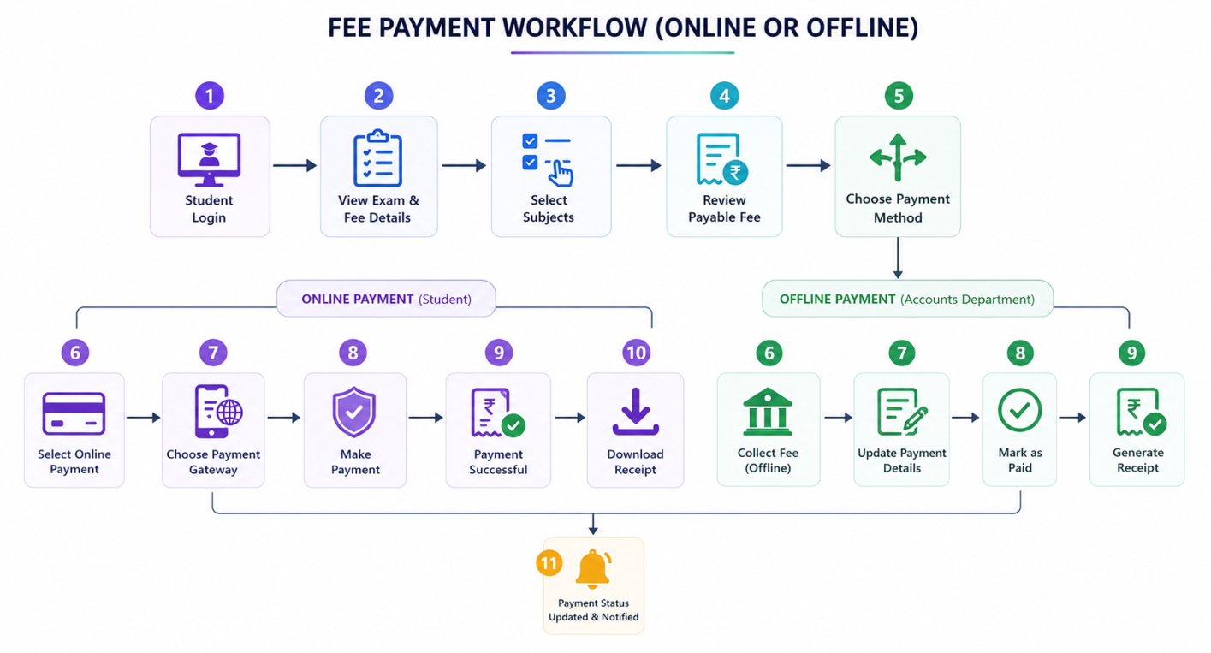

Workflow 10: Late Fee & Fine Management

Overview
The Late Fee & Fine Management module automatically calculates and applies additional charges to students who fail to complete their examination fee payment within the prescribed application period.
The system continuously monitors examination fee due dates and updates student fee records based on the configured late fee rules established during examination creation. This eliminates manual fee calculations while ensuring compliance with institutional examination policies.
The module supports multiple late fee slabs, configurable fine structures, and automatic recalculation of the final payable amount until the examination registration period closes.

Purpose
The primary objective of this module is to automate the enforcement of late payment policies by applying configurable penalties after the examination registration deadline.
The system ensures fairness, transparency, and consistency in fee collection while reducing administrative effort.

Functional Flow
- System scheduler checks all active examinations.
- Compare current date with examination due date.
- Identify unpaid examination fee records.
- Verify applicable late fee configuration.
- Apply appropriate late fee slab.
- Update total payable amount.
- Notify students about updated fee.
- Record all changes in audit logs.

Late Fee Configuration
Each examination can have one or more late fee slabs.
Example:
Payment Period | Additional Fee
Before Due Date | ₹0
1 – 5 Days After Due Date | ₹100
6 – 10 Days After Due Date | ₹250
11 – 15 Days After Due Date | ₹500
Beyond Last Date | Registration Closed
The late fee configuration is fully customizable during examination setup.

Workflow 11: Reports & Analytics

Overview
The Reports & Analytics module provides comprehensive reporting and visualization capabilities for the Examination Management System. It enables administrators, examination cell personnel, and accounts staff to monitor examination activities, fee collections, student registrations, payment trends, and overall examination performance through interactive dashboards and downloadable reports.
The module supports both real-time operational reports and historical analytical reports to assist in institutional planning and decision-making.

Purpose
The primary objective of this module is to provide accurate, real-time insights into examination operations while reducing manual reporting efforts and improving administrative decision-making.

Functional Flow
- Authorized user accesses the Reports module.
- Selects report category.
- Applies filters (Examination, Regulation, Course, Branch, Batch, Semester, Date Range).
- System retrieves report data.
- Generates summary and detailed reports.
- Displays interactive dashboards.
- User exports reports in PDF or Excel format.

Available Reports

Examination Reports
- Examination Summary
- Published Examinations
- Examination Schedule
- Examination Status
- Examination Statistics

Student Reports
- Eligible Students
- Registered Students
- Hall Ticket Issued
- Absent Students
- Student Examination History

Fee Reports
- Fee Collection Summary
- Pending Fees
- Paid Students
- Late Fee Collection
- Offline Collection Report
- Online Payment Report

Financial Reports
- Daily Collection
- Monthly Collection
- Payment Gateway Summary
- Cash Collection
- Bank Collection
- Revenue Analysis

Result Reports
- Pass Percentage
- Subject-wise Performance
- Branch-wise Results
- Regulation-wise Results
- Overall Examination Statistics

Dashboard Analytics
The dashboard displays:
- Total Examinations
- Published Examinations
- Active Registrations
- Total Students
- Total Fee Collected
- Pending Fee Amount
- Online vs Offline Payments
- Hall Tickets Generated
- Results Published

Business Rules
- Reports are generated based on user permissions.
- Financial reports are accessible only to authorized personnel.
- Reports support filtering and exporting.
- Dashboard statistics update automatically.
- Large reports are generated asynchronously.

Output
- Interactive Dashboard
- PDF Reports
- Excel Reports
- Statistical Charts
- Financial Summaries

Workflow 12: Notification Workflow

Overview
The Notification Workflow module provides automated communication between the Examination Management System and users. It delivers timely notifications to students, examination staff, and administrators whenever important examination events occur.
The notification engine supports multiple communication channels to ensure users remain informed throughout the examination lifecycle.

Purpose
The objective of this module is to automate communication and reduce manual follow-ups by delivering real-time examination-related notifications.

Functional Flow
- System event occurs.
- Notification service receives the event.
- Identify target recipients.
- Prepare notification content.
- Deliver through configured channels.
- Record notification history.
- Track delivery status.

Notification Events
The system sends notifications for:
- Examination Published
- Fee Generated
- Fee Due Reminder
- Late Fee Applied
- Payment Successful
- Payment Failed
- Hall Ticket Available
- Examination Reminder
- Result Published
- General Announcements

Notification Channels
- Email
- SMS
- In-App Notification
- Push Notification
- WhatsApp (Optional)

Business Rules
- Notifications are event-driven.
- Failed deliveries are retried automatically.
- Duplicate notifications are prevented.
- Notification history is maintained.
- Users receive notifications based on their role.

Output
- Real-time Notifications
- Delivery Status
- Notification History
- User Alerts

Workflow 13: Audit & Activity Logs

Overview
The Audit & Activity Logs module records every critical system operation performed by users and automated processes. It provides complete traceability of examination activities, ensuring accountability, security, and compliance with institutional policies.
Every significant action within the Examination Management System is logged for future reference and auditing.

Purpose
The primary objective of this module is to maintain a secure and tamper-resistant history of system activities for monitoring, troubleshooting, and compliance purposes.

Functional Flow
- User performs an action.
- System captures event details.
- Audit information is generated.
- Activity is stored in the audit database.
- Administrators can search and review logs.
- Audit reports are generated when required.

Logged Activities
The system records:
- User Login
- Logout
- Regulation Creation
- Subject Creation
- Subject Mapping
- Examination Creation
- Examination Approval
- Examination Publication
- Fee Generation
- Payment Transactions
- Hall Ticket Generation
- Marks Upload
- Result Publication
- Role Changes
- Permission Changes
- System Configuration Updates

Audit Information
Each log contains:
Field | Description
User ID | User performing the action
User Role | System role
Action | Activity performed
Module | Affected module
Timestamp | Date and time
IP Address | User IP
Device Information | Browser / Device
Previous Value | Before update
Updated Value | After update
Status | Success / Failure

Business Rules
- Audit logs cannot be modified.
- Every critical action is recorded.
- Financial activities are always logged.
- Logs are searchable.
- Only authorized administrators can access audit logs.

Output
- Activity History
- Audit Reports
- Security Logs
- Compliance Reports

Workflow 14: Role & Permission Management

Overview
The Role & Permission Management module implements Role-Based Access Control (RBAC) to ensure that users can access only the functionalities relevant to their responsibilities.
Every system operation is protected by permission-based authorization, providing a secure and scalable access management framework.

Purpose
The objective of this module is to provide secure, flexible, and centralized user authorization while preventing unauthorized access to sensitive examination data.

Functional Flow
- User logs into the system.
- Authentication is verified.
- User role is identified.
- System loads assigned permissions.
- Accessible modules are displayed.
- Unauthorized actions are restricted.
- User activities are monitored.

User Roles

Super Administrator
- System Configuration
- User Management
- Role Management
- Permission Management
- Reports
- Audit Logs
- Complete System Access

Note: All other characters in between Super Admin and Student will be dynamically created by administrator

Student
- Dashboard
- View Examinations
- Pay Examination Fee
- Download Receipt
- Download Hall Ticket
- View Results
- Payment History

Permission Categories
- Dashboard
- Regulations
- Subjects
- Subject Mapping
- Examinations
- Fee Management
- Payment Collection
- Hall Tickets
- Marks
- Results
- Reports
- Notifications
- User Management
- Audit Logs
- System Settings

Business Rules
- Every user is assigned at least one role.
- Permissions are role-based.
- Users may have multiple roles if required.
- Unauthorized operations are blocked automatically.
- Permission changes are recorded in audit logs.
- Sessions are validated before every protected request.

Output
- Secure User Authentication
- Role-Based Module Access
- Permission-Controlled Operations
- Complete Authorization Management
- Secure Administrative Control
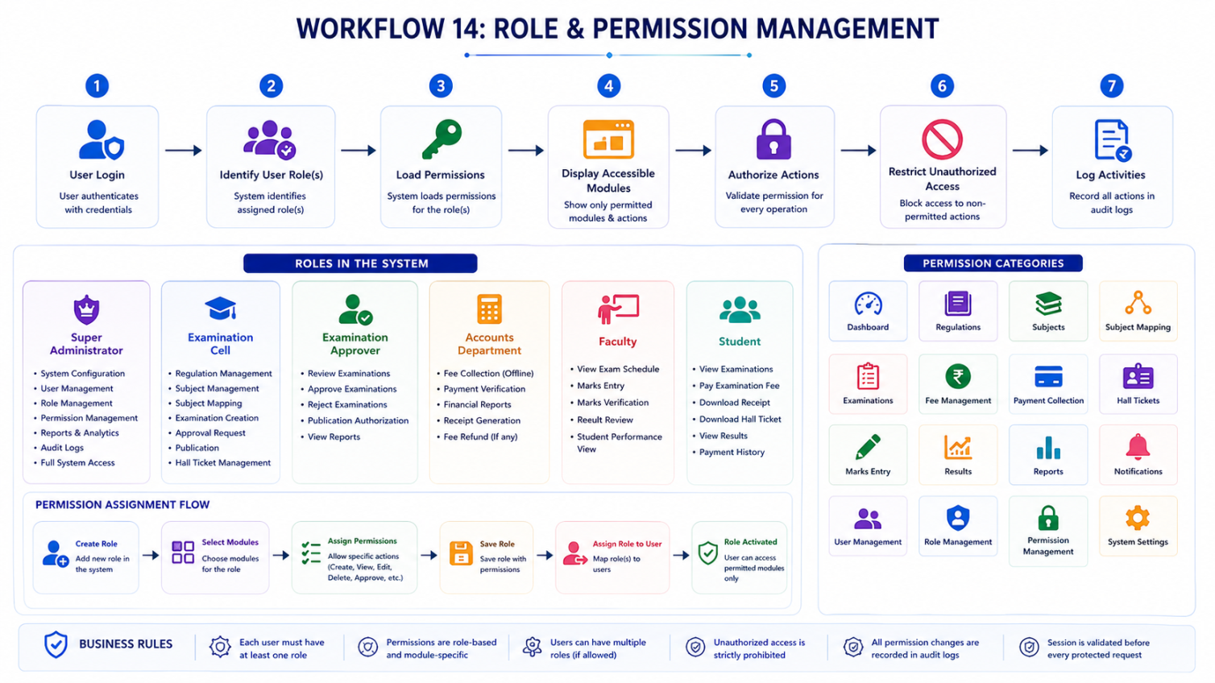

Conclusion

Summary
The Examination Management System (EMS) is designed to provide a centralized, scalable, and secure platform for managing the complete examination lifecycle within an educational institution. By integrating with the existing Student Data Management System (SDMS), the platform eliminates redundant data management while focusing entirely on examination orchestration.
The system automates every major examination-related process, including regulation management, subject configuration, examination creation, approval workflows, fee generation, online and offline fee collection, late fee management, notifications, reporting, and role-based access control. This automation minimizes manual intervention, improves operational efficiency, and enhances transparency for students, examination administrators, and accounts personnel.
The modular architecture ensures that each functional component operates independently while seamlessly integrating with the overall system. This design supports future scalability, maintainability, and integration with additional institutional services.
Overall, the Examination Management System establishes a robust digital ecosystem that simplifies examination administration and provides a reliable, user-friendly experience for all stakeholders.

Expected Outcomes
Upon successful implementation, the system will provide:
- A centralized examination management platform.
- Automated examination orchestration.
- Reduced manual administrative effort.
- Secure online and offline fee collection.
- Accurate fee calculation with configurable late fee policies.
- Seamless integration with the SDMS Portal.
- Real-time reporting and analytics.
- Improved transparency and accountability.
- Secure role-based access control.
- Comprehensive audit and activity tracking.
- Enhanced student experience through digital services.

Final Statement
The Examination Management System is designed as a modern, modular, and enterprise-ready platform that streamlines the complete examination lifecycle—from academic configuration and examination planning to fee management, payment processing, hall ticket generation, and result publication. Through seamless integration with the existing SDMS, configurable business rules, secure role-based access control, and scalable architecture, the system provides a reliable foundation for efficient examination administration while enhancing the experience of students, administrators, and institutional stakeholders. This architecture also ensures the platform remains adaptable to future academic, operational, and technological requirements.

